ACTIVE STABILITY SCOOP SYSTEM (AS³)
Deployable Aerodynamic Surfaces for Emergency Attitude, Drag, and Glide Assistance
Proof-of-Concept White Paper
Revision 0.1 — August 2026
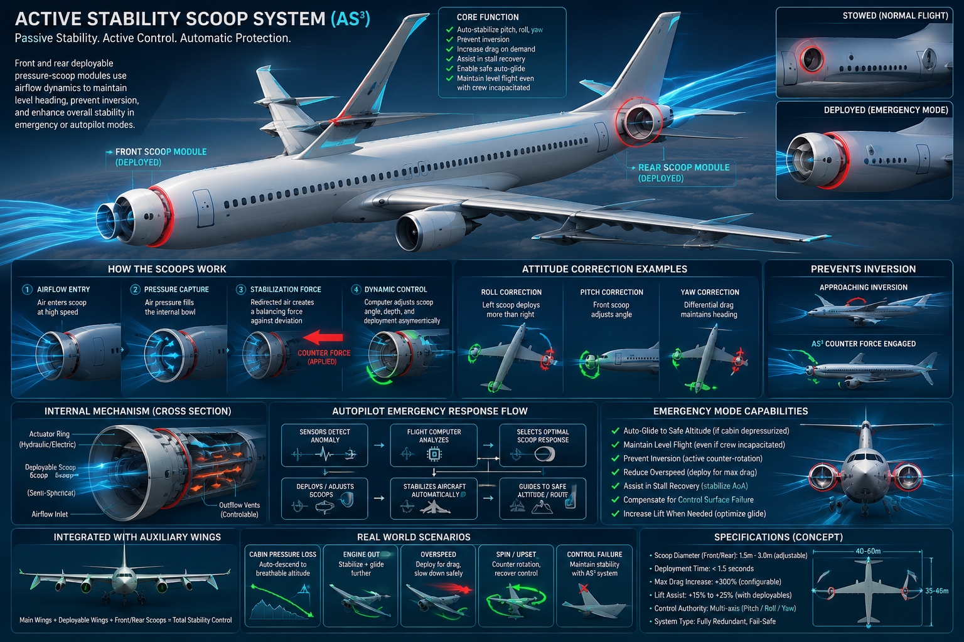

Abstract
This paper defines a proof-of-concept (POC) for an emergency aerodynamic augmentation system that combines deployable auxiliary lifting surfaces with independently controllable fore/aft and left/right drag-producing surfaces (“stability scoops”). The central hypothesis is that temporary, rapidly deployable aerodynamic authority could enlarge the recoverable flight envelope during selected loss-of-control, overspeed, propulsion-loss, or crew-incapacitation scenarios. The concept is deliberately framed as a research hypothesis rather than a claim that passive air pressure can inherently keep an aircraft level or prevent inversion. Whether the system provides net safety benefit must be established through aerodynamic modeling, controls analysis, structural assessment, failure-mode analysis, simulation, and subscale testing.

1. Problem Statement
Transport aircraft already use redundant flight controls, spoilers, speed brakes, high-lift devices, trim systems, autopilots, envelope protections, and carefully designed static/dynamic stability. Nevertheless, some emergencies can reduce available control authority, create excessive energy, degrade lift-to-drag performance, or incapacitate the crew. AS³ asks a narrow engineering question: can normally stowed surfaces provide useful emergency-only aerodynamic forces without creating hazards greater than the hazards they are intended to mitigate?

2. Concept Architecture
The proposed architecture has two cooperating subsystems. First, compact auxiliary wing panels remain stowed in normal flight and deploy to increase effective lifting area or provide additional control authority. Second, independently actuated scoop/drag surfaces are positioned at separated longitudinal and lateral stations so that differential deployment can create moments as well as drag. A flight-control computer commands the surfaces from measured aircraft state; aerodynamic pressure supplies the resulting force, while actuators set geometry.
Element | POC Function | Key Question
Auxiliary wing panels | Increase area / alter lift distribution | Can useful lift be added without unacceptable loads or stall behavior?
Fore/aft scoops | Generate drag or pitching moment | Is the moment strong and predictable across the emergency envelope?
Left/right differential surfaces | Generate yaw/roll damping or correction | Can coupling between axes be controlled?
Flight-control logic | Closed-loop deployment and retraction | Can the controller remain stable with failures and bad sensor data?
Fail-safe actuation | Defined stow/deploy behavior after faults | What is the safest state for each failure mode?

3. Operating Principle
Dynamic pressure scales approximately as q = ½ρV². Any deployed surface therefore produces forces that vary strongly with airspeed, density, angle of attack, sideslip, geometry, and local flow. AS³ would exploit those forces through controlled surface area and orientation. Symmetric deployment could add drag; differential deployment could create yaw or roll moments; fore/aft differences could contribute pitching moment. Auxiliary panels could potentially change lift and glide characteristics. These effects cannot be assumed from geometry alone and are primary POC test items.

4. Candidate Emergency Modes
- Loss of thrust: evaluate whether auxiliary surfaces improve controllability or usable glide envelope after propulsion loss.
- Overspeed/high-energy upset: evaluate symmetric drag deployment while respecting structural load limits.
- Incipient unusual attitude: evaluate differential surfaces as supplemental—not replacement—control authority.
- Decompression or crew incapacitation: integrate with an automated emergency-descent function that uses conventional flight controls first and AS³ only where validated.
- Partial control-surface degradation: determine whether AS³ provides meaningful residual authority when conventional control is limited.

5. Control-System Concept
The POC should use closed-loop control rather than relying on passive self-leveling. Inputs would include inertial attitude/rates, calibrated airspeed, altitude, angle of attack, sideslip where available, surface position, and aircraft configuration. The controller estimates the current envelope, determines whether AS³ deployment is permitted, selects a bounded command, monitors the response, and retracts or degrades gracefully when the response is inconsistent with the model. Pilot authority, explicit inhibit logic, and independent reversion paths are essential research requirements.

6. Fail-Safe Philosophy
A pressure- or spring-biased deployment mechanism is attractive because it may retain functionality after some power failures, but automatic deployment itself can be hazardous. The POC must therefore test both fail-stowed and fail-deployed cases. No single actuator, sensor, controller, latch, hydraulic leak, electrical fault, or asymmetric deployment should be allowed to create an unrecoverable condition. The design objective is bounded, predictable behavior—not unconditional self-leveling.

7. Proof-of-Concept Test Program
Phase 1 — Analytical model: Define geometry, mass properties, hinge moments, aerodynamic coefficients, deployment envelope, and first-order loads.
Phase 2 — CFD / low-order aerodynamics: Map forces and moments versus Mach, Reynolds number, angle of attack, sideslip, and deployment state.
Phase 3 — Six-degree-of-freedom simulation: Insert aerodynamic tables into a nonlinear aircraft model and test nominal and upset trajectories.
Phase 4 — Control-law development: Design bounded allocation for pitch/roll/yaw/drag objectives; test sensor and actuator faults.
Phase 5 — Wind-tunnel model: Measure coefficients, unsteady loads, buffet, interference, and deployment transients.
Phase 6 — Subscale unmanned demonstrator: Conduct progressive, geofenced flight tests beginning with benign symmetric deployments.

8. Minimum POC Success Criteria
A successful POC does not require proving that AS³ prevents crashes. It should demonstrate measurable, repeatable aerodynamic authority; stable closed-loop behavior within a defined envelope; tolerable structural and deployment loads; no catastrophic single-point failure in the evaluated architecture; and a quantified comparison against the same aircraft using conventional controls alone. Metrics should include attitude-rate damping, heading/flight-path error, peak load factor, airspeed reduction, altitude loss during recovery, glide ratio, actuator energy, and time to stabilized flight.

9. Critical Risks and Open Questions
- Large drag devices can produce destabilizing moments, buffet, flow separation, or control coupling.
- Deployment at high dynamic pressure may create severe transient and structural loads.
- Additional mechanisms add mass, maintenance burden, failure modes, and certification complexity.
- Added lifting surfaces can alter stall progression and may not improve glide if their drag penalty dominates.
- Fore/aft fuselage installations must be assessed for pressure-vessel, bird-strike, icing, lightning, evacuation, radar/sensor, and maintenance impacts.
- Emergency automation must distinguish true loss-of-control from sensor faults and must not fight the pilot or conventional flight-control laws.

10. Conceptual System State Machine
NORMAL/STOWED → anomaly detection → VALIDATE (multi-sensor consistency + envelope check) → ARMED → bounded deployment → RESPONSE MONITORING → either STABILIZED/ASSIST, RETRACT, or DEGRADED MODE. A hard inhibit applies outside validated airspeed/Mach/load/configuration limits. This state machine should be implemented first in simulation, with every transition logged.

11. Research Deliverables
- Parametric CAD geometry and mass estimate.
- Aerodynamic coefficient database for each deployment state.
- 6-DOF simulation and repeatable emergency test cases.
- Preliminary control allocation and state-machine software.
- Structural load cases and actuator sizing bounds.
- FMEA/FHA-style hazard register and mitigation matrix.
- Wind-tunnel test report and go/no-go recommendation for a subscale demonstrator.

12. Conclusion
AS³ is best treated as an emergency aerodynamic-control research platform: deployable surfaces that may provide extra drag, lift, or moment authority when the normal configuration is insufficient. The compelling part of the concept is not the claim that airflow will automatically force an aircraft upright; it is the possibility of adding spatially separated, independently commanded aerodynamic effectors and integrating them with modern sensing and flight-control logic. The next credible step is a simulation-led POC that measures where the concept helps, where it is neutral, and where it becomes hazardous.

Appendix A — Concept Visualization
The following image is a conceptual visualization only. Dimensions, performance values, airflow paths, and depicted capabilities are illustrative and are not validated engineering specifications.
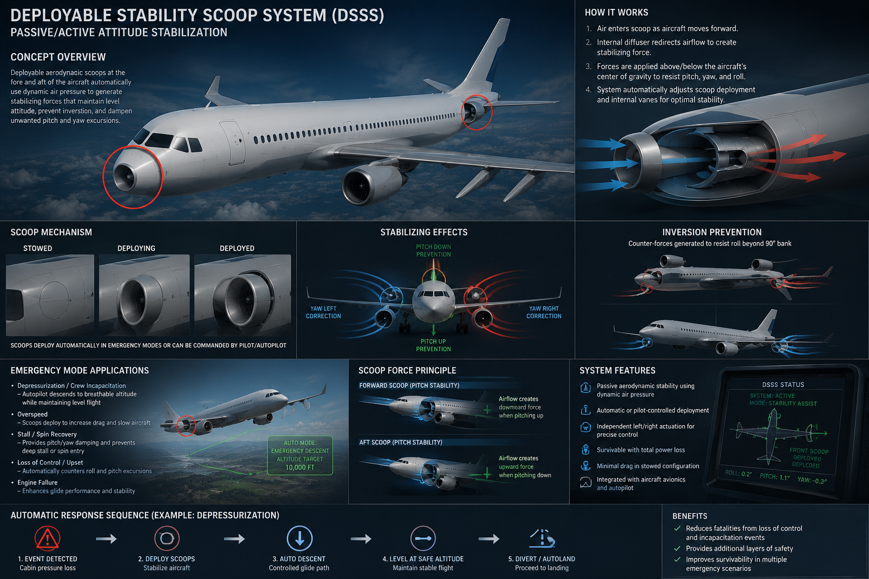

Appendix B — POC Assumptions
Baseline assumptions for the first model: conventional twin-engine transport-class configuration; AS³ inactive during normal operation; no credit for AS³ in baseline airworthiness; deployment limited by an explicitly modeled envelope; independent surface-position feedback; conventional flight controls retained; and all safety/performance benefits treated as hypotheses until demonstrated.

